Digital Logic Families:

## 1) Speed of operation:

The speed of a digital circuit is specified in terms of the propagation delay time. If the propagation delay time is lower, the speed of the IC is higher.

2) Power of dissipation:

This is the amount of power dissipated in an IC. It is determined by the current, ICC, that it draws from the VCC supply, and is given by VCC * ICC.

ICC is the average value of ICC(0) and ICC(1). This power is specified in milliwatts.

3) Figure of merit:

The figure of merit of a digital IC is defined as the product of speed and power. The speed is specified in terms of propagation delay time expressed in nanoseconds.

*Figure of merit = propagation delay time (ns) * power (mW)*

It is specified in pico joules (ns * mW = pJ).

A low value of speed-power product is desirable. In a digital circuit, if it is desired to have a high speed, low propagation delay time, then there is a corresponding increase in the power dissipation and vice versa.

4) Fan Out:

Fan out is the number of similar gates which can be driven by a gate. High fan-out is an advantage because it reduces the need for additional drivers to drive more gates.

5) Current and voltage parameters:

High Level Input Voltage(VlH) : This Is The Minimum Input Voltage Which Is Recognized By The Gate As Logic 1.

Low Level Input Voltage(VlL) : This Is The Maximum Input Voltage Which Is Recognized By The Gate As Logic 0.

6) Noise immunity:

The input and output voltage levels are defined above are shown in figure. Stray electric and magnetic fields may induce unwanted voltages, known as noise, on the connecting wires between logic circuits. This may cause the voltage at the input to a logic circuit to drop below VlH or rise above VlL and may produce undesired operation.

|  |
| --- |
| Noise Immunity & Noise Margin in Logic Gates - YouTube |
| Noise immunity |

So, the circuit's ability to tolerate noise signals is referred to as the noise immunity, a quantitative measure of which is called Noise Margin.

7) Operating temperature range:

The temperature range by which a IC functions properly must be known. The accepted temperature ranges are: 0 to 70 degree Celsius for consumer and industrial applications and -55 degree Celsius to 125 degree Celsius.

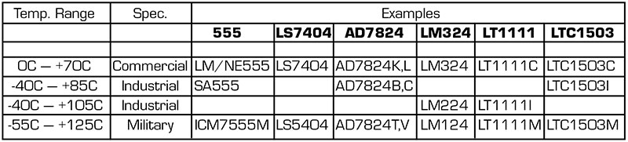

Operating Temperature Range

8) Power supply requirements:

The supply voltage and the amount of power required by an IC are important characteristics required to choose the proper power supply.